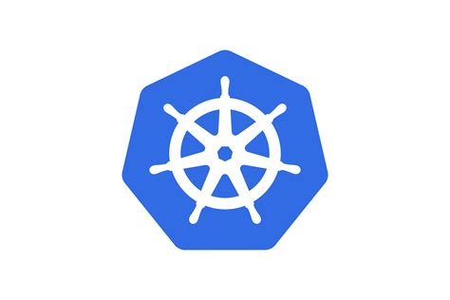

KUBERNETES DEPLOYING A POD USING SINGLE NODE HANDS-ON COMMANDS

SINGLE NODE ARCHITECTURE
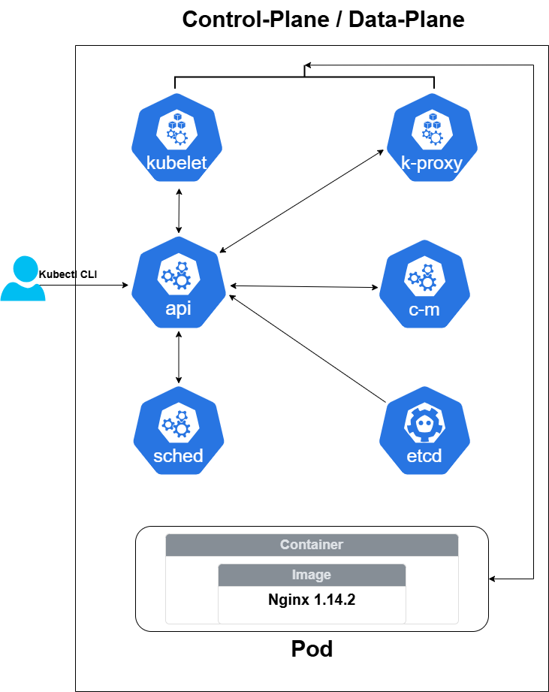

Prerequisites:
- Install Kubectl
- Install Minikube

Kubectl Installation Check:
After installing kubectl, open Command prompt and type “kubectl”. If you are getting the same output as below, then you can confirm kubectl is successfully installed.

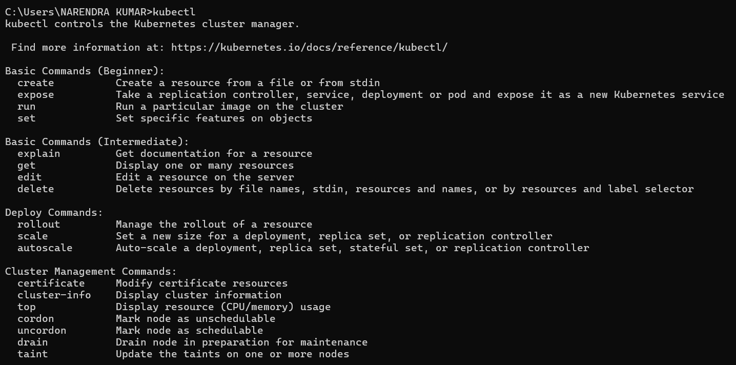

Minikube Installation Check:
After installing Minikube, open Command prompt and type “minikube”. If you are getting the same output as below, then you can confirm minikube is successfully installed.

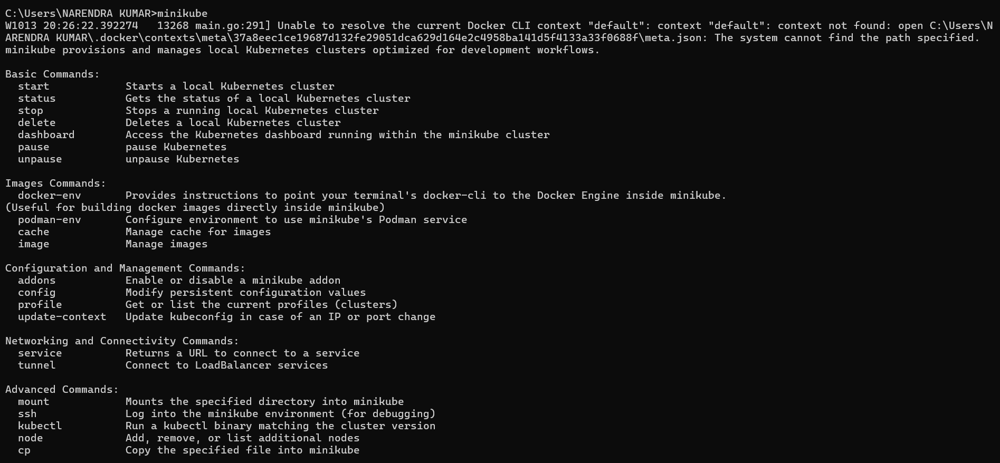

Note: For installation of Kubectl and Minikube follow the Kubernetes documentation. Links are given at the end of the document.

DEPLOYING AN NGINX WEB SERVER USING PODS
STEP 1: Create and start the Kubernetes cluster. You can do that using the below single command. After executing you can see the below output.
$ minikube start
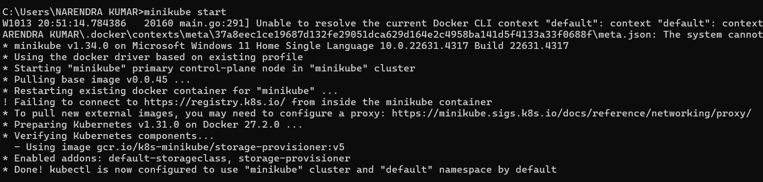

STEP 2: After having the cluster, you have to connect with that cluster and get the nodes. After executing the below command, you will get the nodes you have.
$ kubectl get nodes
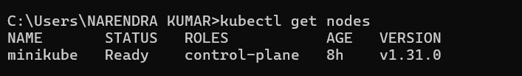
By default, only one node will get created that acts as both control-pane and data-plane. Here the node is in ready status and name is minikube. This is Single Node Architecture.

STEP 3: Next we have to create pods. For creating pods, we should have an yml code that specifies how the pod should get created. Below is the “pod.yml” code that I have followed for simplicity.
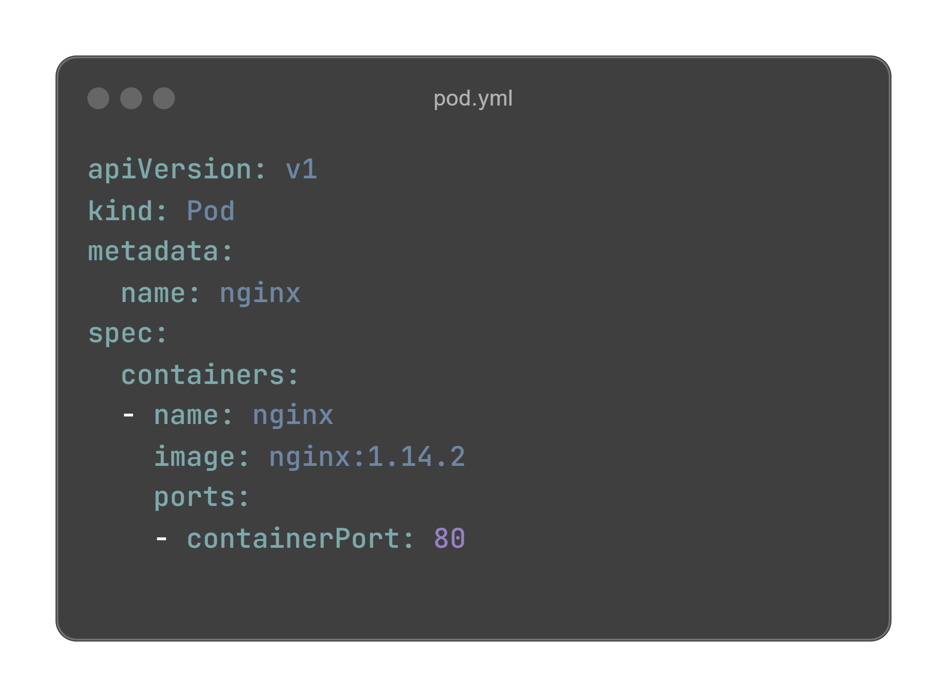
- Since we are creating pod, the kind key should have the value, Pod. And we are creating a container inside the pod using the image nginx:1.14.2. And the containerPort is 80.

- Without the yml code we are unable to create the pods in Kubernetes.

STEP 4: Now create the pod using the “pod.yml” file. By Executing the below command, the pod will get created and automatically runs. Here -f represents file.
$ kubectl create -f pod.yml
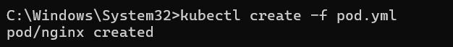

- If you want to see the running pods, use the below command.
$ kubect get pods

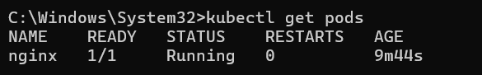

- If you want to see the full details about the pods, use the below command.
$ kubectl get pods -o wide

Here -o represents the output.

STEP 5: Access the Nginx server. In order to access the server, first you need to login to the Kubernetes cluster. For logging in you need to do SSH. Use the below command to do that.
$ minikube ssh

STEP 6: After doing SSH, request that IP address using Curl command. After doing that you will see the basic home page html code of Nginx Webserver.
$ curl 10.244.0.5

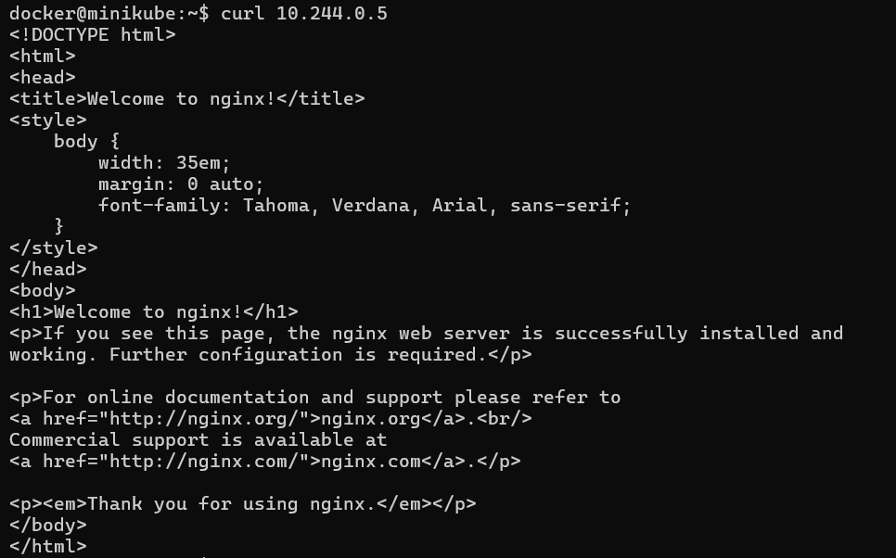

STEP 7: We can also see the complete details about the particular pod using the following command.
$ kubectl describe pod nginx
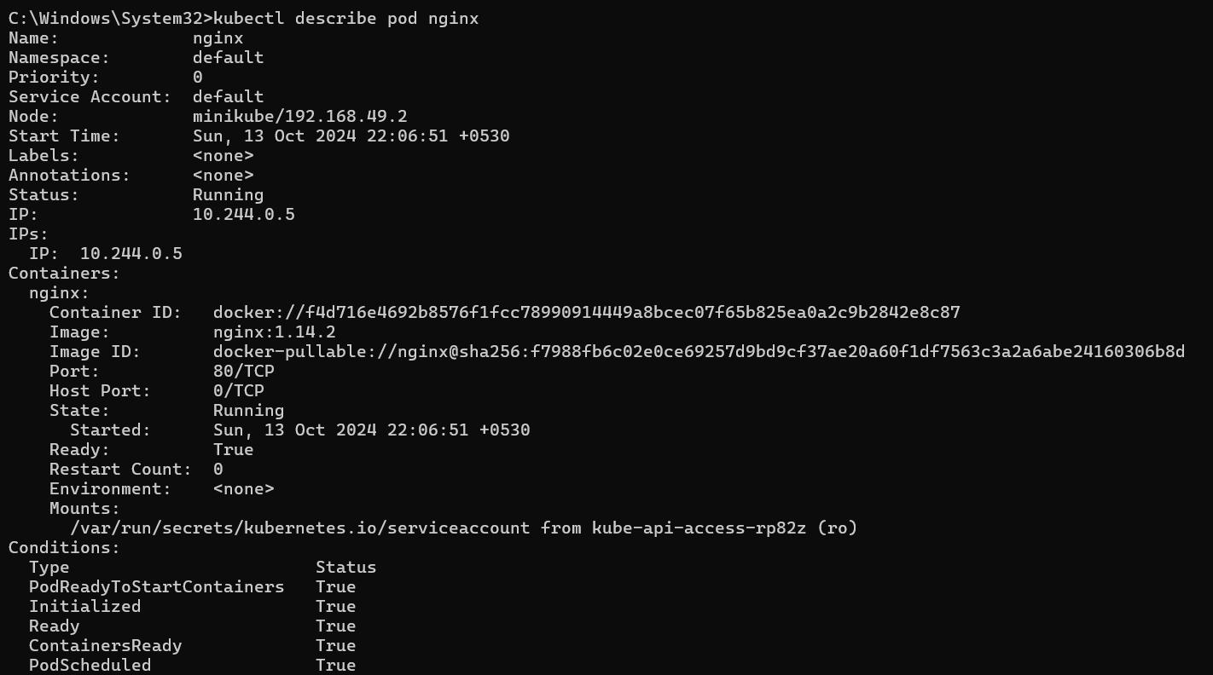

STEP 8: We can also see the logs of the pod using the below command.
$ kubectl logs ngnix

- You can also delete the pod using the following command.
$kubectl delete pod nginx

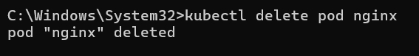

THIS IS HOW WE CAN DEPLOY THE APPLICATION USING PODS

REFERENCES

- Install and Set Up kubectl on Windows |Kubernetes

- minikube start | minikube (k8s.io)

- Pods | Kubernetes

- Kubernetes Pods | Deploy Your First App |YouTube

